

**Faculty of Engineering & Applied Science**

**Experiment Name:** **Wireless communication between an Arduino and raspberry Pi**

**Experiment date: 10/26/2022**

**Group Number*: 4***

**Section CRN: 44432**

**Course Instructor: *Ramiro Liscano***

**Lab TA:*****Sifatul Mostafi***

| **Student Name** | **Student Id** |
| --- | --- |
| Preet Patel | *100708239* |
| Tiwaloluwa Ojo | *100700622* |
| Waleed El Alawi | *100764573* |

**Learning Objective**

The objective from this lab was to learn and understand bluetooth communication and to test Mosquitto by sending test data between two clients and to use python code to test and send messages using Mosquitto. We learned how to communicate readings from the DHT11 temperature and humidity sensor connected with the Arduino UNO board to the Raspberry Pi using the DSD HC-05 bluetooth module.

**Deliverables**

**Task 1 AT Command with HC Module:**

Steps:

1. Connect the bluetooth HC module and the Arduino UNO board
2. Write, compile and upload the code to the Arduino board so AT commands can be sent to the board
3. Enter AT commands (AT, AT+ADDR?, AT+NAME?, AT+UART?) using the serial plotter and monitor in the Arduino IDE to get outputs of the commands in the terminal

Output of AT commands (AT, AT+ADDR?, AT+NAME?, AT+UART?) being sent to the Arduino UNO board to get device name, address, and baud rate:

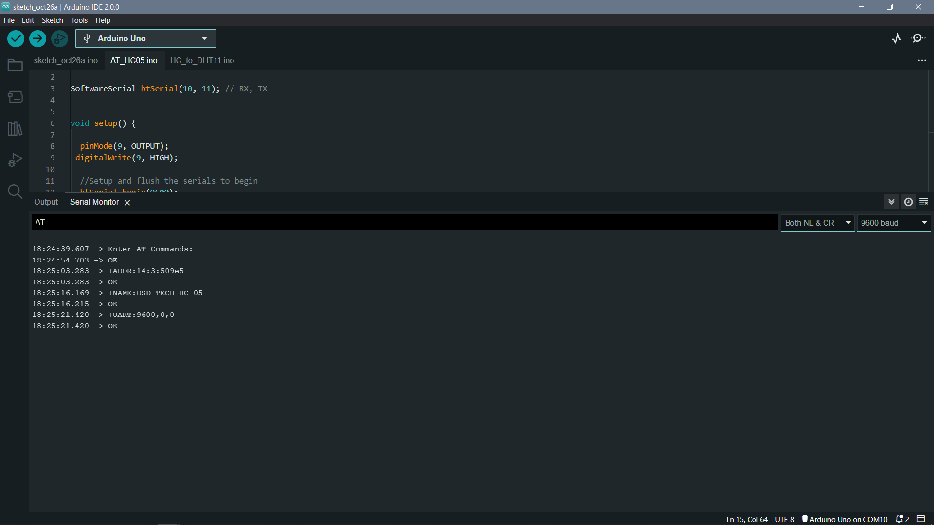

**Task 2 Obtain Temperature and Humidity sensor data from Arduino via Bluetooth:**

Steps:

1. Connect the Wifi shield to the Arduino UNO board and connect the temperature sensor and the HC bluetooth module to the Arduino UNO board using the wifi shield
2. Write, compile and upload the program to perform temperature data extraction from the temperature sensor to the Arduino UNO board
3. Open the Arduino IDE terminal to look at the readings from the temperature sensor.

Source code and output of the C program performing temperature data extraction from the temperature and humidity sensor and displaying the temperature in the arduino terminal:

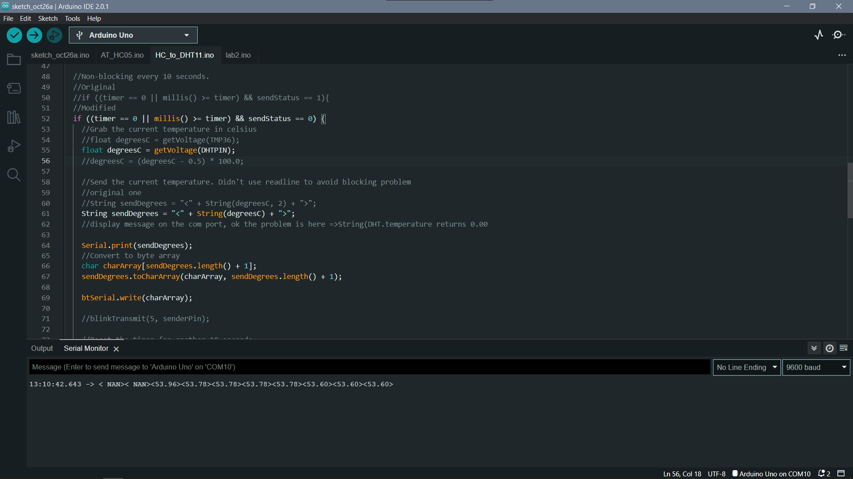

**Task 3 Obtain messages between the raspberry pi and Arduino periodically:**

Steps:

1. Start the Raspberry Pi
2. Write and upload the python code to the Raspberry Pi which will retrieve temperature data from the HC module on the Arduino UNO board
3. Bind the Raspberry Pi rfcomm with the HC bluetooth module connected with the Arduino UNO board
4. Run the python code on the Raspberry Pi to retrieve the temperature data readings being collected by the temperature sensor on the arduino board (shown in lab task 2)

Source code and output of the C program performing temperature data extraction from the temperature and humidity sensor and displaying the temperature in the arduino terminal from lab task 2:

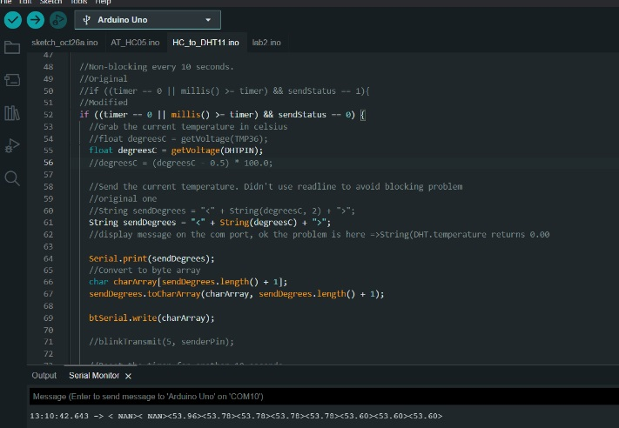

Output of the python code which retrieves the temperature data readings being collected by the temperature sensor on the arduino board being communicated via the HC bluetooth module:

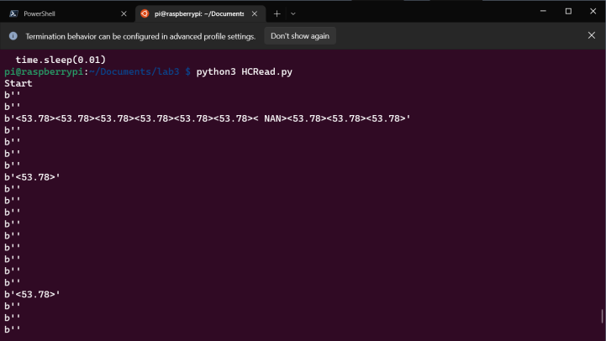

Side by side picture showing the readings from the arduino being communicated to the Raspberry Pi:

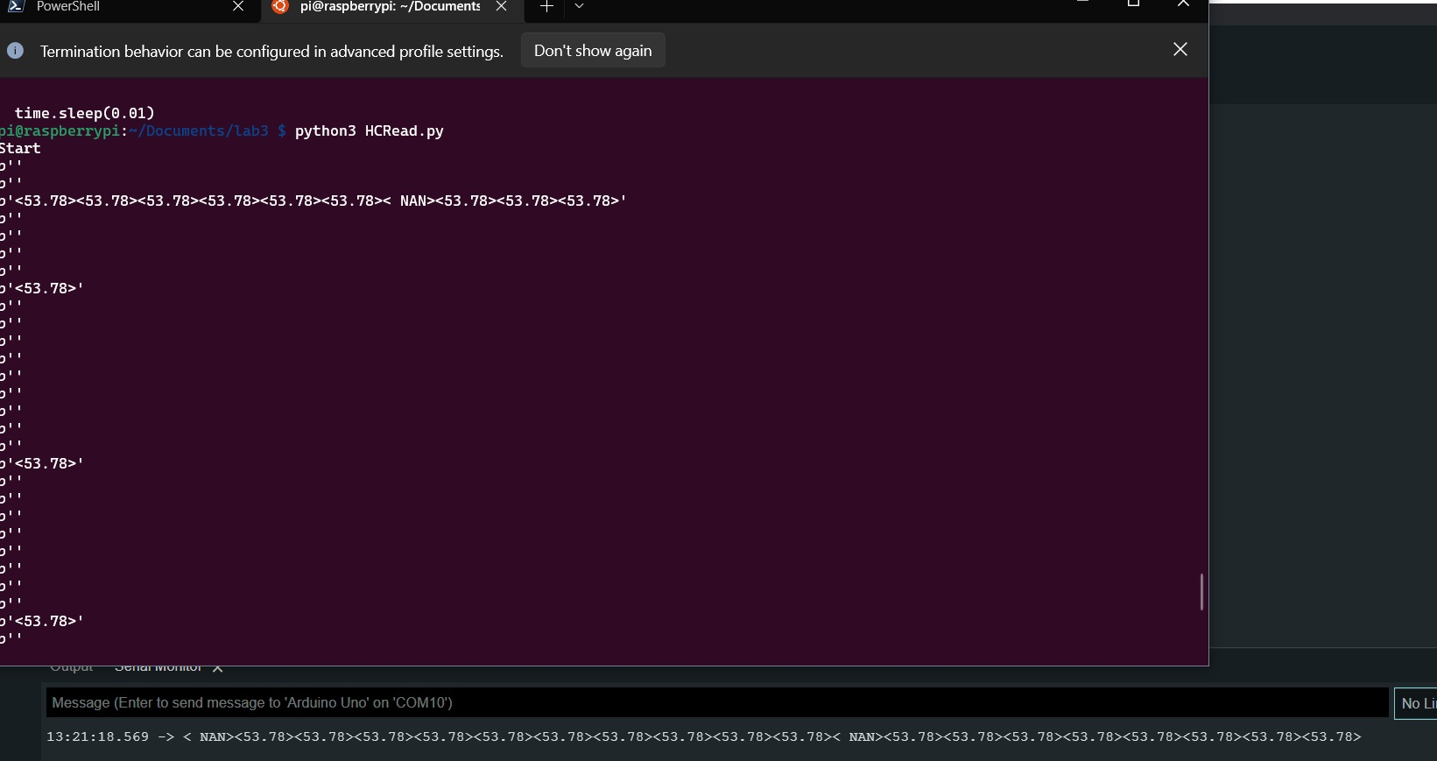

**Conclusion**

In conclusion, we were able to connect the HC bluetooth module with the Arduino UNO board and use AT commands to retrieve the device name, device address, and the device baud rate of the board. Then we connected the Wifi shield to the Arduino UNO board along with the HC bluetooth module and temperature sensor. We learned how to write an Arduino code to retrieve the temperature readings from the sensor and display it on the Arduino IDE terminal display. In the final task of the lab, we used the HC bluetooth module to communicate the temperature readings from the sensor with the Raspberry Pi over a bluetooth connection. We learned how to write a python code on the Raspberry Pi which will retrieve the temperature readings using bluetooth from the Arduino UNO board.